**ie**

User Guide for OCTAV system

Hardware and software use guide

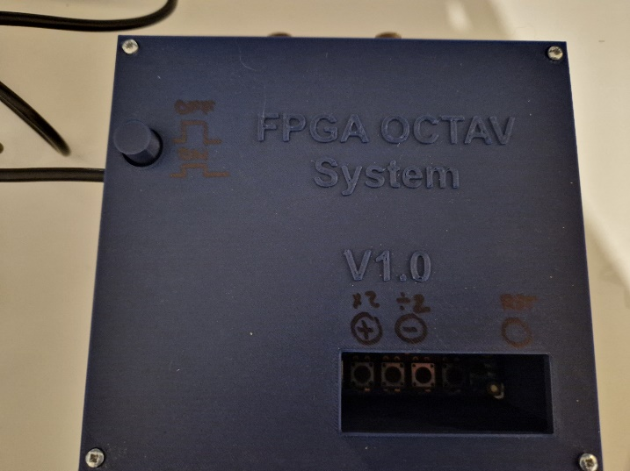

Table of Contents

. Introduction 4

UNBOXING AND INSTALLATION 5

I. System Components 5

1. FPGA Box 5

2. Microphones 6

3. Power connection 7

II. Software Installation 7

1. Full installation 7

2. Update the software 7

STARTUP 8

I. Connect components 8

II. Starting and using the software 9

1. Starting the soft 9

2. Configuration of the serial port (COM port) 10

3. Launching the visualization and recording. 12

4. Opening the data into Excel 14

DEVICE SETTING OPTIONS 16

I. Adjust basic settings (inputs/outputs). 16

II. Advanced settings (jumpers configurations) 17

TROUBLESHOOTING 18

I. Hardware issues 18

II. Software errors 18

III. Connection issues 18

1. Transmission errors 18

2. Com port 18

SAFETY AND MAINTENANCE 19

TECHNICAL SPECIFICATIONS 21

I. FPGA Development Board 21

II. Conditioning Circuit 21

III. Microphones 21

IV. FTDI Cable 22

# . Introduction

The near-real-time sonogram display system is an innovative tool designed to record, process, and visualize rodent vocalizations in the ultrasonic frequency range, which is beyond human hearing. This system is part of the larger OCTAVie project, aiming to provide an open-source, low-cost solution for studying animal communication, particularly in neuroscience research. It enables real-time processing of ultrasonic signals, significantly reducing the need for extensive post-recording processing by directly producing spectrograms that map vocalizations across time, frequency, and amplitude.

The system integrates various hardware and software components to deliver efficient signal processing and data management. It eliminates the bottleneck of excessive data storage and time-consuming signal analysis, paving the way for more accessible research in animal behavior. Explain hardware and software requirements.

The first prototype successfully integrates an ultrasonic microphone, analog anti-aliasing filters, an FPGA-based FFT processing unit, and a computer interface for data transfer. It achieves real-time conversion of rodent vocalizations into visual spectrograms, with the FFT implemented on the Cyclone V GX FPGA development board. This prototype also features a C-based software application to capture and save FFT frames received via serial communication (Real time Graphic Interface Interface).

However, **several aspects are still under development**, including:

* Optimal Power Resolution: Fine-tuning the power calculation step to determine the best 12-bit representation of the 24-bit FFT output.
* Enhanced Data Transfer Methods: Exploring alternative high-speed communication protocols to improve data throughput and system scalability for multi-channel inputs.

________________________________________

# UNBOXING AND INSTALLATION

## System Components

The system is composed of several parts: The FPGA box, the power cable and the microphone. The different parts will be detailed in this part.

### FPGA Box

The FPGA box (**Figure 1**) includes several internal components: the FPGA development board, the analog filter that conditions the signal, and the FTDI cable needed to connect to the computer.

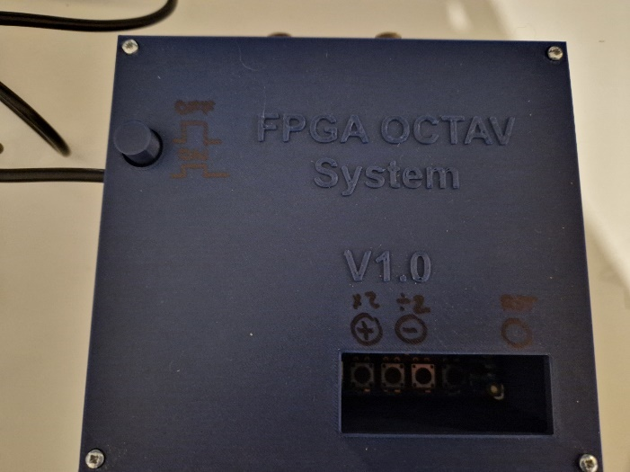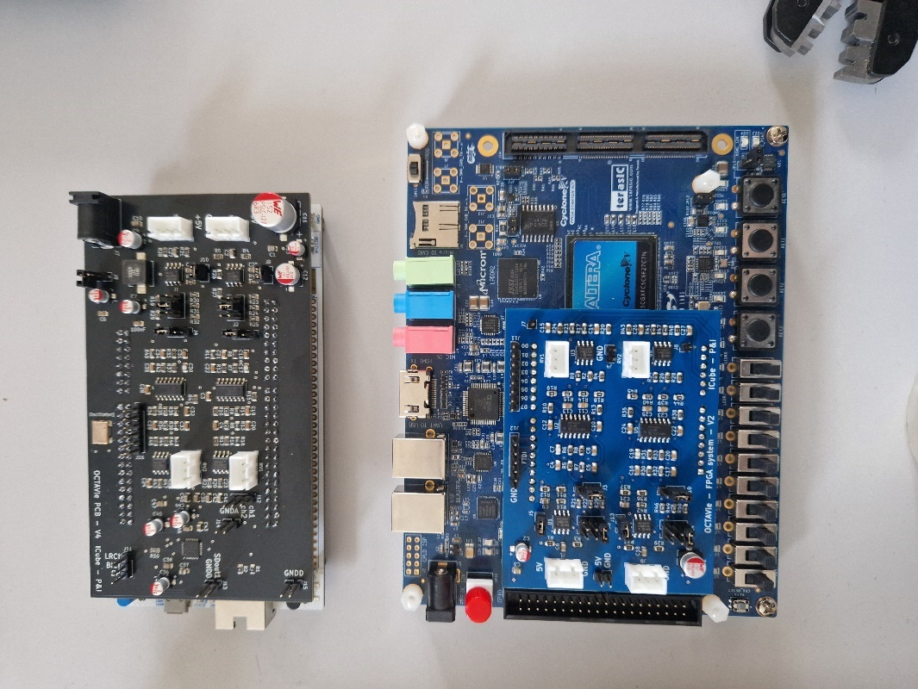

Figure 1:On the left, FPGA box V1.0 containing the circuit shown on the right.

**Note: The current version of the box must remain upright since the FPGA board is not securely fixed within the box.**

**Description of the FPGA box**

The FPGA box features:

* Front: Two rotary knobs to adjust gain (**Figure 2**-A)
* Left Side: USB cable and power plug (**Figure 2**-B)
* Back: Two XLR female connectors (**Figure 2**-C)
* Top: Start button on the top left, with a small access window for the development board buttons (**Figure 2**-D)

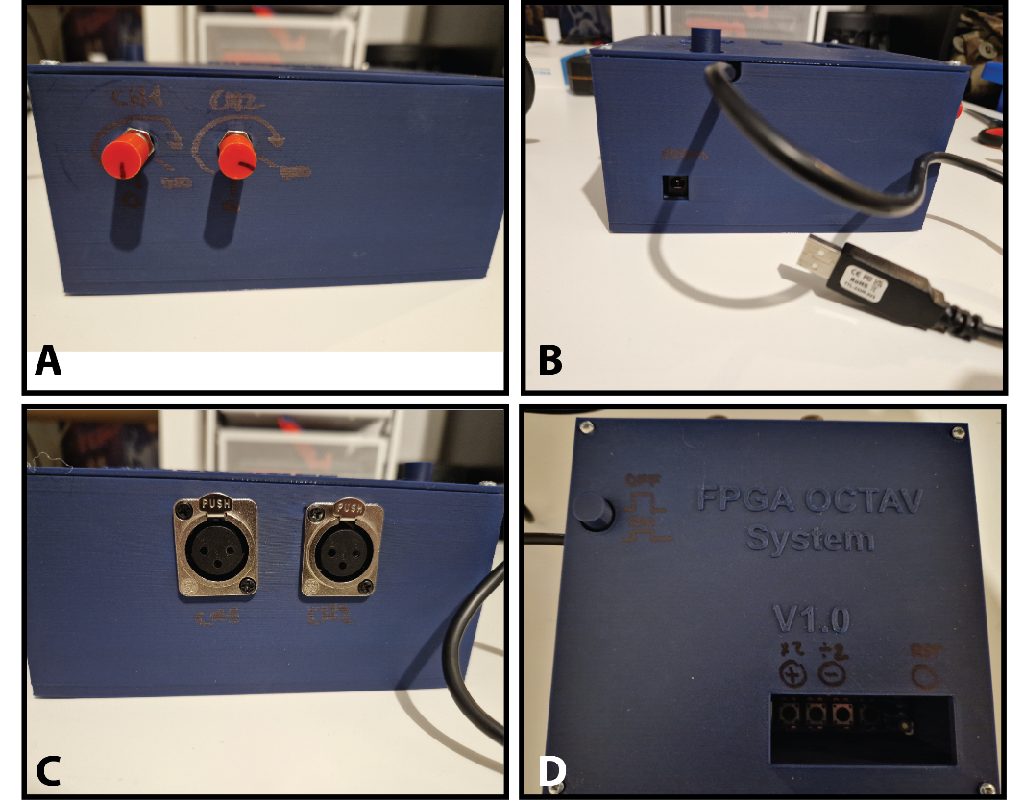

Figure : the front (A), the left side (B), the back (C) and the top view (D) of the FPGA box.

### Microphones

Microphones (**Figure 3**) are designed to include a built-in signal amplification (x100).

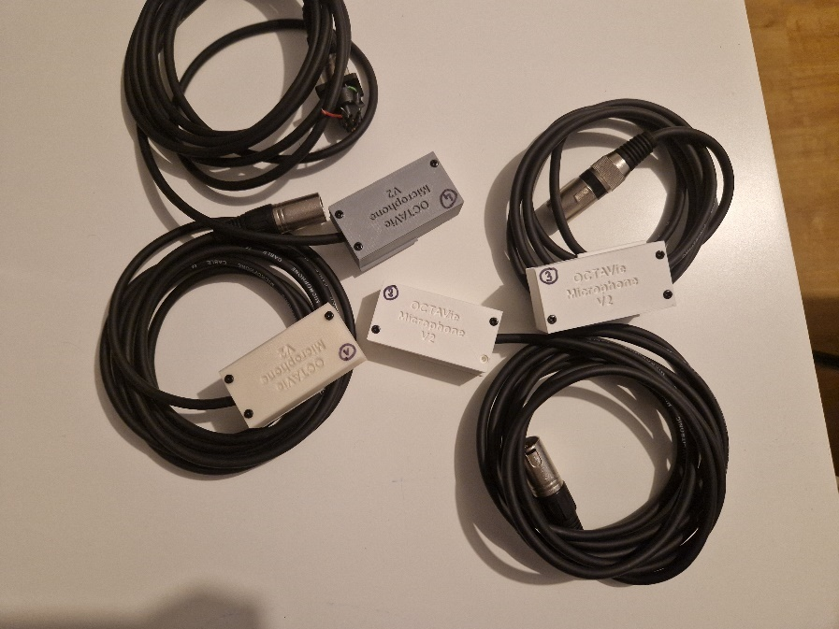

Figure : Microphones in their housing and their XLR connections.

**Note**: Characteristics such as sensitivity and signal-to-noise ratio were not tested directly due to the lack of appropriate testing equipment. The numerical data provided is sourced from the microphone's data sheet.

Microphones can be mounted on adjustable supports (**Figure 4**), allowing them to be easily oriented toward the animal cage.

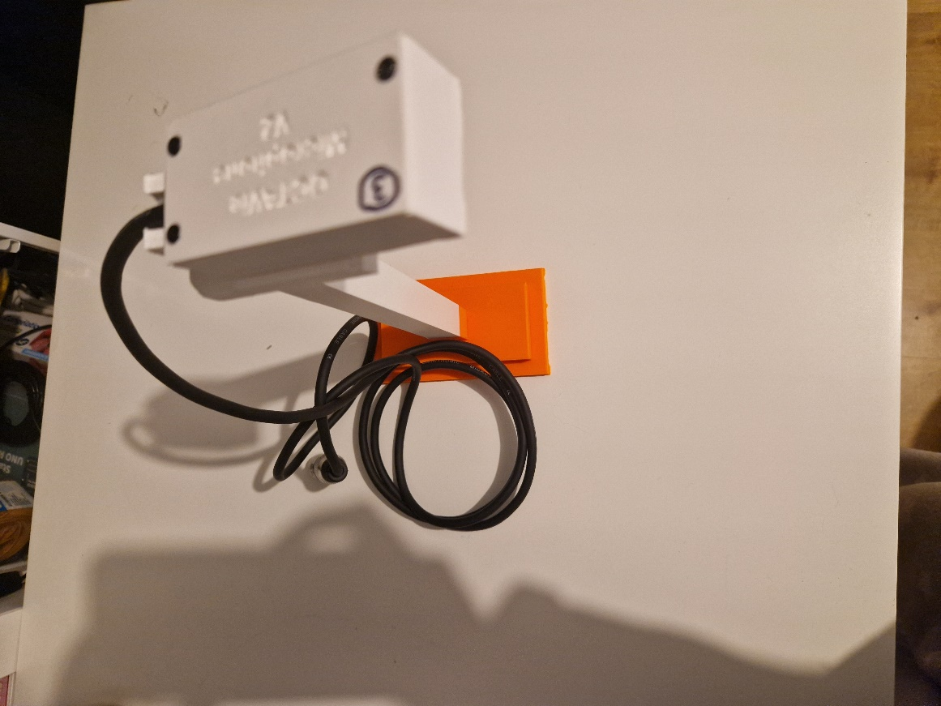

Figure : Microphone and its support.

### Power connection

The FPGA development board is accompanied by a power cable. Kindly ensure that only the provided cable is used.

## Software Installation

### Full installation

The procedure for installing the software will be included in the manual shortly.

### Update the software

Coming soon.

________________________________________

# STARTUP

## Connect components

Connect the power supply to the left side of the FPGA box (**Figure 5**) and plug the XLR microphone into the back. From the rear view, channel 1 is on the left and channel 2 is on the right (labeled on the box – **Figure 6**).

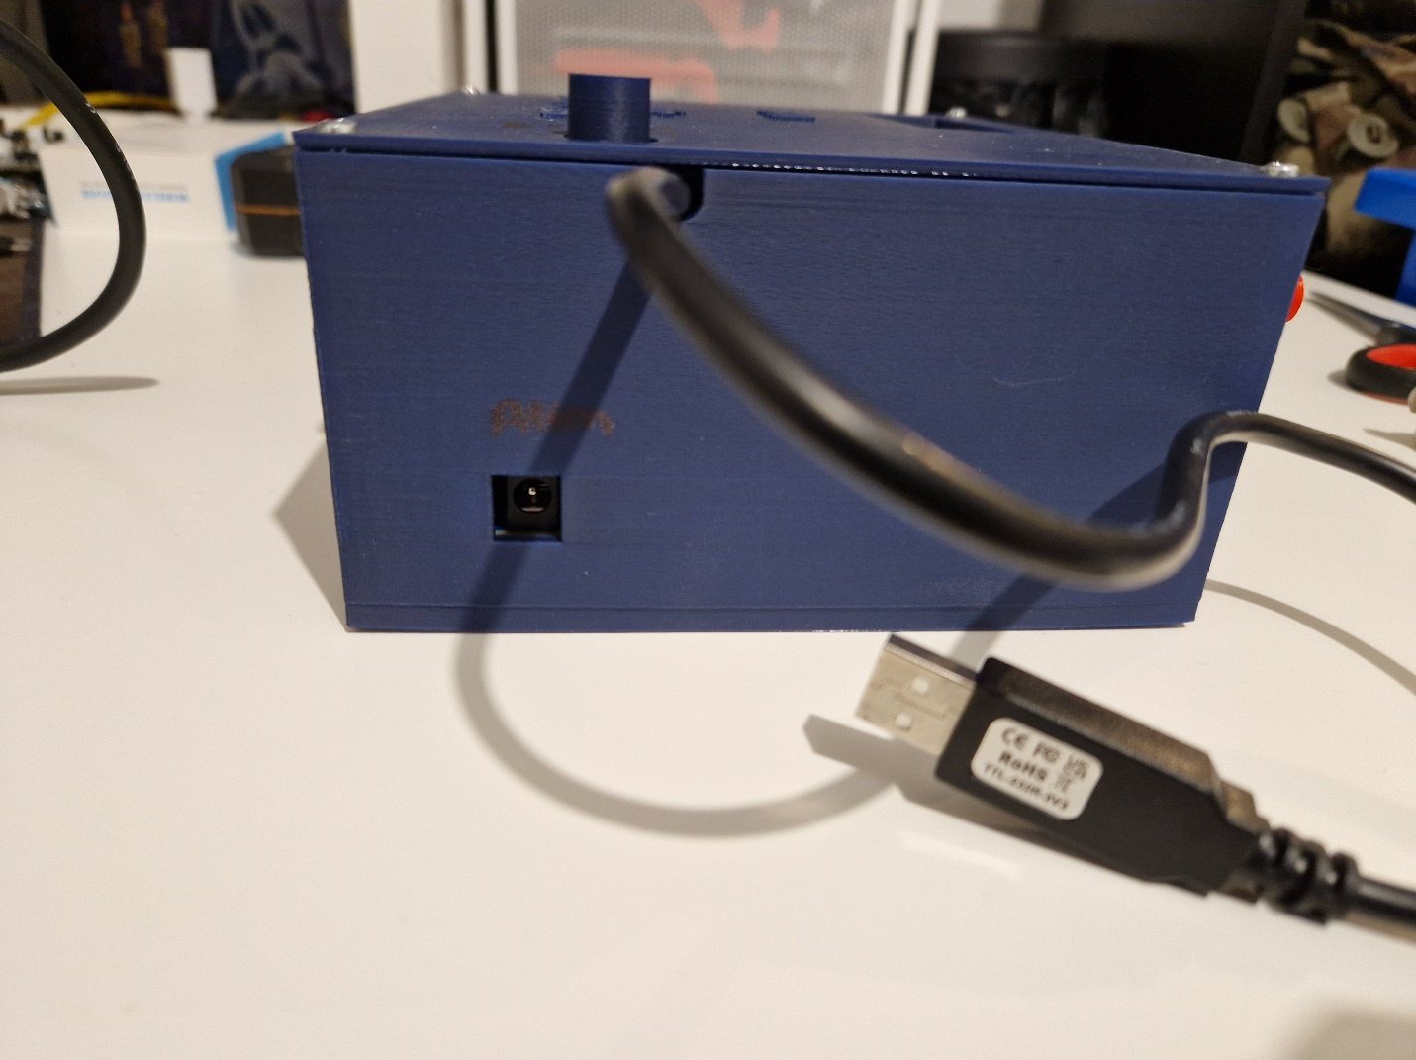

Figure : Left side of the box with the hole to plug the power cable.

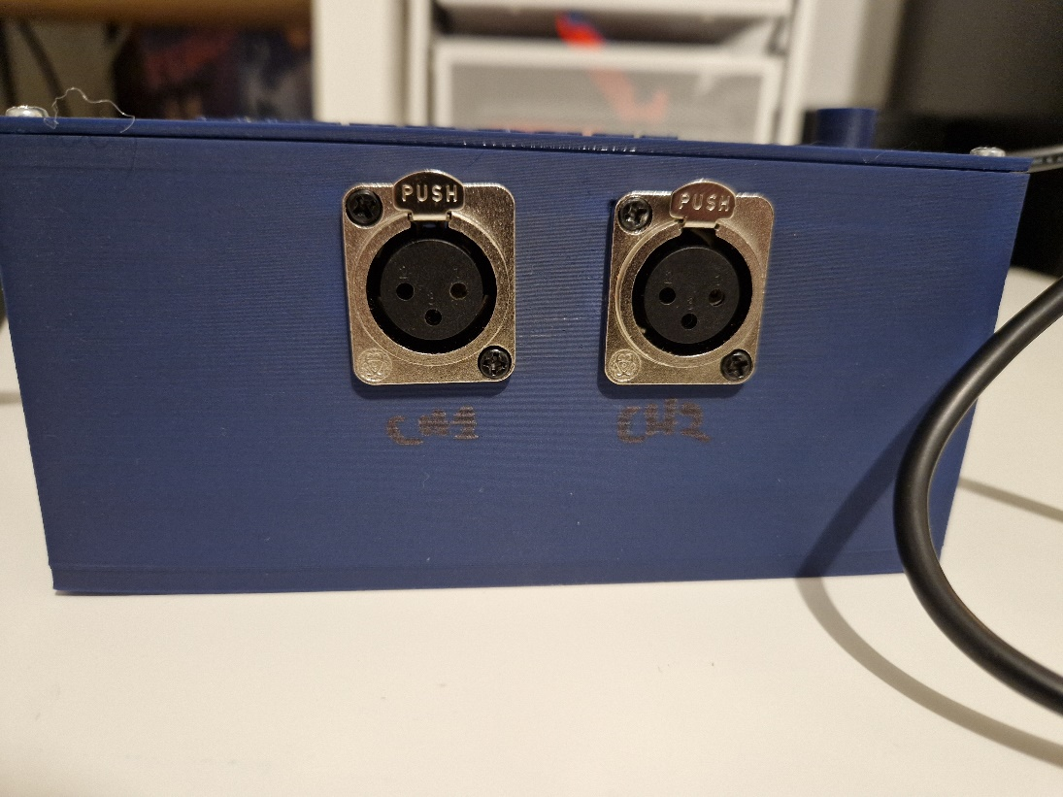

Figure : The deux XLR plugs to connect the microphones.

Please be advised that only the difference between the two microphones will be recorded. If you wish, you can connect with a single microphone. In this instance, the recorded signal will emanate solely from the connected microphone, without any subtraction applied.

Connect the USB cable from the left side of the FPGA box to your computer. After completing this step, you can proceed to power on the device by pressing the button located on the top (refer to **Figure 7**). The device is powered on when the button is in the down position and powered off when the button is in the up position.

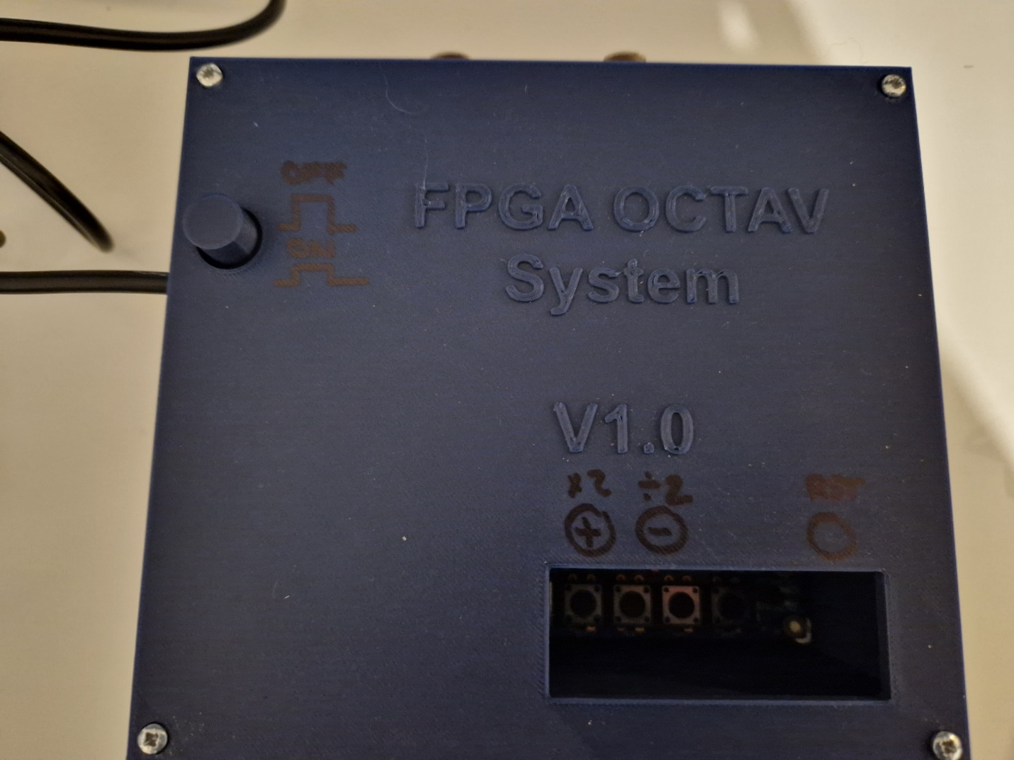

Figure : The top view of the FPGA box with the power button located on the left side of the image.

Upon initialization of the FPGA, an LED will be observable blinking through the window located at the top of the enclosure designated for button access.

## Starting and using the software

Please note that this tutorial is specifically designed for Windows users. Although the software is compatible with Linux, guidelines for Linux users will be provided at a later date.

### A computer screen shot of a blue square Description automatically generatedStarting the soft

Double-click on the OCTAVie icon located on the desktop.

A black command window will open (**Figure 8**) that displays OCTAVie information messages.

Figure : Command window where OCTAVie software can display information.

After a few seconds, the GUI OCTAVie will open (**Figure 9**). Please allow time for the interface to fully launch.

Figure : OCTAVie GUI.

### Configuration of the serial port (COM port)

Right click on the Windows start button:

Then select "device manager" (or "gestionnaire de périphérique" in French - **Figure 10**).

Figure : Windows right click menu.

A window will open displaying all the peripherals of the computer. Please note that a small window may appear indicating that modifications are restricted to administrators (read-only). Disregard this message and click "OK".

Select the small arrow next to "Ports (COM and LPT)" as illustrated in **Figure 11**.

Figure : Device manager menu.

Several lines may appear below the menu. Locate the one starting with "USB Serial Port". Please enter the same number associated with the port into the Com port field in the graphical interface (**Figure 12**). If no lines match, ensure that the device is powered on and the USB is properly connected. Should these conditions be met and the issue persists, try using an alternative USB port on your computer. If this still does not resolve the problem, please contact us using the information provided at the end of this document. If multiple lines correspond to "USB Serial Port", unplug the USB from the device and reconnect it. The line that disappears and reappears will be the correct one.

Figure : Indication of the com port to OCTAVie software.

At this stage, please change the name of the file in the “Output file” field (**Figure 13**). This is the name of the file where the data will be saved. You may choose any name you prefer, but ensure it ends with “.csv.” For optimal processing, avoid using special characters, except for the underscore (“_”).

Example: manip_XXX_ratXXX_250120.csv

**Important**: If you neglect to change the name and a file with that name already exists, the existing data will be **overwritten**.

Note: Windows users should not modify the “Com path.”

Figure : OCTAVie interface with an example of the file name.

### Launching the visualization and recording.

Click the Start button (**Figure 13**) in OCTAVie to visualize the data. Note that this action only visualizes the data and does not record it.

Figure : Start button location on OCTAVie interface.

On the command terminal, you should see this message:

If the message does not display, it likely means that you have not configured the com port correctly. Please refer to the earlier section for guidance. Another possibility is that the com port is already in use, as only one software can access the com port at a time. This possibility is less common, but you should ensure that OCTAVie is not opened more than once.

To check data reception, you can snap your fingers in front of the microphone, which should produce a response on the graph as shown in **Figure 15**. Alternatively, you can strike two metal objects together, and this should generate a response similar to the one displayed in **Figure 16**. Note that both examples also show large responses across all frequencies, which are transmission errors. Be aware of their shape to avoid confusing them with actual responses.

Figure : Spectrogram with the frequency response to clapping fingers in front of the microphone. The blue circles represent the real response, and the red lines represent the transmission errors..

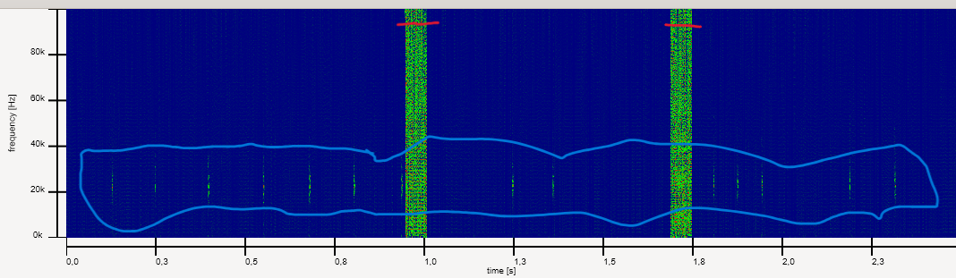

Figure : Spectrogram with the response of clapping two metal objects together (weakly), highlighted with the blue circle. The red lines represent the transmission errors

At this stage, it is essential to adjust the amplitude of the signal to ensure that it is sufficient to capture rodent vocalizations accurately. Please refer to the next chapter for information on the available options within the system to manage the recording amplitude (the sensitivity).

Once the settings have been configured satisfactorily, you may proceed with initiating the data recording.

To start the data recording, please left click on the “Record” button in the OCTAVie interface window, as illustrated in **Figure 17**.

Figure : Location of the Record button in OCTAVie interface.

In the command terminal, you should see appear the following message:



Once the recording has started, to stop it, please left click on the "Stop" button in the OCTAVie interface window.

The following message should appear in the command terminal to confirm the completion of the recording and display.

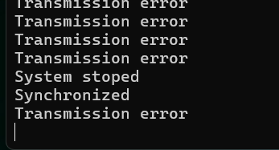

**Important**: Set the COM port before starting ("Start" button) and write down the name of the file before recording ("Record" button). If the COM port is not valid, the software will not be able to read the data. Additionally, if the file name already exists in the folder containing the recorded data, it will be **erased** **without warning** after clicking the "Record" button. Ensure that the "Start" button is clicked and data is displayed BEFORE clicking the "Record" button. Otherwise, the CSV file created will be empty.

Advice: COM port -> file name -> START -> RECORD (if needed) -> STOP -> file name -> START -> RECORD (if needed) -> STOP. Note that the COM port only needs to be set when opening the software. If you do not close it, you do not need to set the COM port again.

### Opening the data into Excel

You will find your recorded data in the same folder as the executable (.exe). For example:

Documents => Octavie_soft

**Important**: Do not open the file during recording.

Open this file in Excel as usual. The rows represent time points with a resolution of 2.56 ms, and the columns represent frequencies with a resolution of 390Hz.

Be aware that if the file is too large, Excel may crash. It is advisable not to open a document with more than 40 minutes (based on calculation) of recording, which is equivalent to one million rows in Excel.

You are now ready to record your data. The next chapter covers the device settings options.

________________________________________

# DEVICE SETTING OPTIONS

There are two primary methods to adjust the amplitude of the recorded signal within the system. Additionally, it is possible to directly adapt the filter (derivator) parameters on the PCB. However, this option should only be utilized by individuals who are proficient with PCBs and jumper settings. The first section of this chapter will explain how to configure the device using the user-friendly rotary and push buttons. The second section will provide detailed instructions on the jumper configurations.

## Adjust basic settings (inputs/outputs).

In this section, you will learn how to set the desired amplitude of the signal. Please note that the microphone provides a fixed amplification of 100.

Vocabulary Note: The gain refers to the amount by which the obtained signal is increased compared to the original signal. In this specific context, it indicates the extent to which the amplitude of the signal generated by the microphone is enhanced.

The rotary knobs (**Figure 18**):

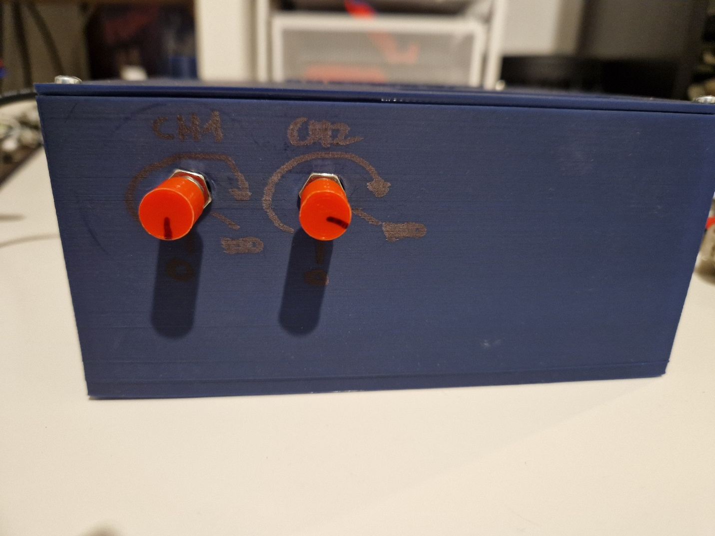

Figure : Rotating knobs to set up the amplification gain.

You can set the amplitude from just under 1 to 100. Each microphone's gain is adjustable using its respective rotative button (left for the first channel, right for the second). Turn clockwise to increase gain and counterclockwise to decrease it.

**Warning**: The rotative button is very sensitive.

Development board buttons (**Figure 19**):

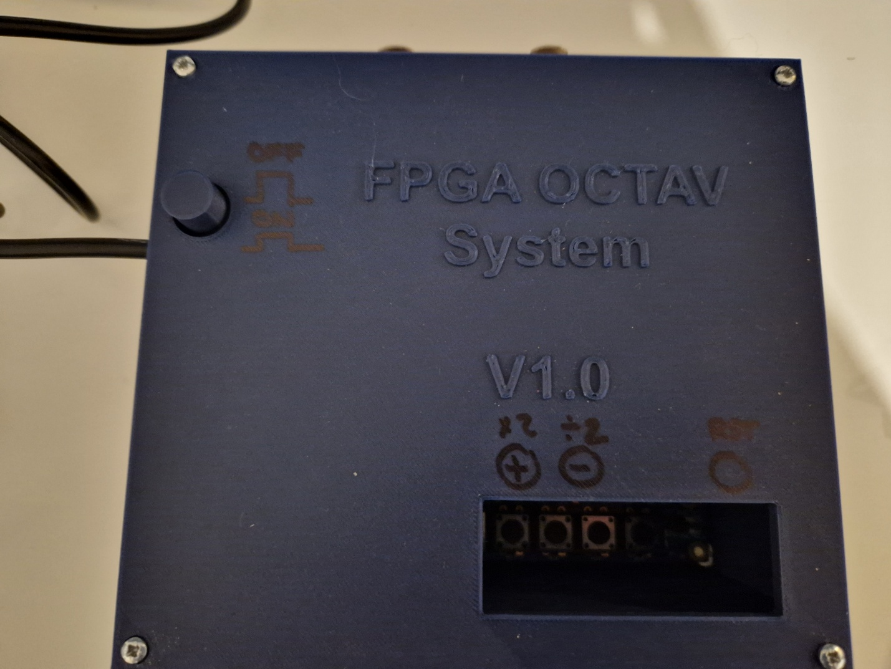

Figure : Push button located in the opening of the FPGA Box. The red button is functional, while the blue button is not programmed (not functional).

The FPGA development board is equipped with four push buttons, accessible through an open window on the top of the box. On the far right (when looking at the front of the box), there is a reset button. The two buttons on the left are used to adjust the gain as needed; the leftmost button is labeled “+” and the second button is labeled “-”.

* **Reset Button**: This button resets the board, restarting the processes running from the beginning. If you encounter unusual FFT results, pressing this button may help by reinitializing the board's memory and restarting all operations.
* **“+” Button**: Increases the signal amplitude by a factor of 2.
* **“–” Button**: Decreases the signal amplitude by a factor of 2.

*Note*: The “+” and “–” buttons have scale limitations. You cannot press the “+” or “-” buttons more than a defined number of times after starting the FPGA. The FPGA always starts from the same point of the scale and does **not save the previous state**. Therefore, it is advisable to note down the state before turning off the FPGA and restore it when starting a new experiment.

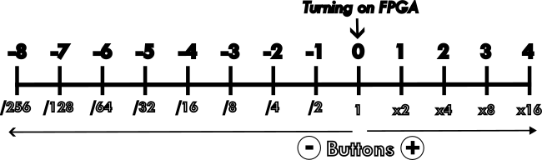

Figure : Scale of the amplification given by the number of clicks on the button "+" or "-".

## Advanced settings (jumpers configurations)

This part is not written for the moment. Please, contact me if you need to know more about that

________________________________________

# TROUBLESHOOTING

This section will address issues as they arise and document the main solutions.

## Hardware issues

If the board does not start, please first check that the power plug is correctly connected at both ends. If the board starts but the LED is not blinking, it indicates an issue with the board's firmware. You will need to re-upload the bitstream file.

## Software errors

Occasionally, we encounter an issue with GTK (C libraries that create the graphical interface) where the image stops displaying for a few seconds. During this time, the FFT graphics will appear white. This issue is likely due to the GTK libraries and is beyond our control. However, it does not affect the recording process. The data will continue to be safely recorded even during this bug. You just need to wait for the GTK issue to resolve.

## Connection issues

### Transmission errors

The primary issue involves transmission errors, which can sometimes be more significant than others. Our current method of transmitting data is simple but not highly secure. It is common to experience one error per millions of octets transmitted, which aligns with our observations. Therefore, a straightforward solution to correct these errors is not feasible. We are considering ways to reduce these errors.

### Com port

If the software indicates that the COM port is not accessible, please verify that the number being used is correct. To do this, follow the steps in the relevant chapter. Once in the "Device Manager," you can plug and unplug the USB cable to ensure that the COM port disappears when unplugged and reappears when replugged. If this does not resolve the issue, check if the COM path has changed (for Windows users). If in doubt, close the software and reopen it.

If help is needed, please contact us.

________________________________________

# SAFETY AND MAINTENANCE

# Versioning

|  |  |  |  |
| --- | --- | --- | --- |
| Authors | Version | Date | Comment |
| L. Durieux | V0.1 | 27.01.25 | Document first release |
| L. Durieux | V1.0 | 04.10.2025 | Formatting |
|  |  |  |  |

________________________________________

# TECHNICAL SPECIFICATIONS

In this part, the main characteristics of the different parts of the system (V1.0)

## FPGA Development Board

The details on FPGA are provided in **Table 1**. Please note that the current version of the box should be kept on the right side, as the FPGA board is not securely fixed within the box.

Table FPGA Development board characteristics.

|  |  |
| --- | --- |
| Characteristic | Description |
| FPGA Model Development Board | Cyclone V GX Starter Kit. |
| FPGA | Cyclone V GX 5CGXFC5C6F27C7N |
| ADC | LTC2308 (12-bit, 500 ksps). |
| Main function | Real-time FFT processing and data transfer. |
| Connections | Microphone (XLR female), power (5 V), FTDI cable for USB transfer. |

## Conditioning Circuit

The characteristics of the conditioning circuit are in the **Table 2**:

Table : Characteristic of the conditioning circuit.

|  |  |
| --- | --- |
| Characteristic | Description |
| Filter Type | Sallen-Key (bandpass filter). |
| Sallen-Key (bandpass filter). | High-pass: 10 kHz; Low-pass: 100 kHz. |
| Derivator | Settable |
| Operational Amplifier | MCP602X (10 MHz gain-bandwidth product). |
| Adjustable Gain | Adjustable via a potentiometer. (from ~1 to ~100) |
| Main Function | Anti-aliasing filtering and signal amplification before digital conversion. |

## Microphones

The characteristics are details in the **Table 3** below.

Table : Main characteristics of the microphones.

|  |  |
| --- | --- |
| Characteristic | Description |
| Model | Knowles SPU0410LR5H-QB. |
| Technology | Piezoelectric MEMS microphone. |
| Frequency Range | 1kHz to 100KHz |
| Sensitivity | -38 dBV/Pa at 1 kHz |
| Signal-to-Noise Ratio | 63 dB(A). |
| Connectivity | XLR males |
| Main Function | Detect ultrasonic sounds up to ~ 100 kHz. |

## FTDI Cable

FDTI cable allows us to bring the data from the FPGA ship to the computer. It translates the UART signal to USB protocol. The characteristics are listed in the **Table 4**.

Table : FTDI Cable characteristics.

|  |  |
| --- | --- |
| Characteristic | Description |
| Model | TTL-232R-3V3. |
| Connection Type | UART (FPGA) to USB (computer) conversion. |
| Baud Rate | 3 Mbps |
| Main Function | Fast and reliable transfer of FFT data to the visualization software on a PC. |

________________________________________